Welcome Herzog Tigers!



Welcome!!!

**I am excited to be the School Social Worker! This is my 4th year here at Herzog. I can’t wait to see what exciting things will happen this year. Let’s start the year off with open and positive minds!**

**Here are a few examples of areas in which I can assist:**

* Attendance Issues
* Students/Families in Transition
* Uniform Assistance
* 100 Neediest Program (Christmas Assistance)
* 1 on 1 or Group Counseling



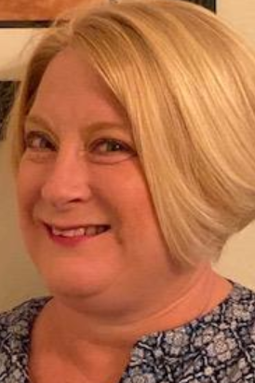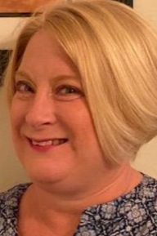

**Meet The Social Worker**

Greetings Families,

 My name is Mrs. McIntosh. I attended Southern Illinois University Edwardsville and I received my Bachelors in Psychology and my Masters in Social Work. Outside of work, I enjoy spending time with my husband and darling daughter. I also love traveling and shopping!

As your School Social Worker here at Mallinckrodt, my goal this year is to ensure that every student’s needs are met and that they are functioning effectively in their learning environment. I also want to make sure that every student is attending school, attentive every day, and learning to the best of their ability. Showing up for school has a huge impact on a student’s academic success starting in kindergarten and continuing through high school. No matter how old the child is, families play a key role in making sure students are logging on daily and teaching students why attendance is so important for success in school and in life.

We realize some absences are unavoidable due to health problems or other circumstances. But, we also know that when students miss too much school— regardless of the reason – it can cause them to fall behind academically.  Your child is less likely to succeed if he or she is chronically absent—which means missing 10 or more days over the course of an entire school year.  We don’t want your child to fall behind in school and become discouraged.  Please ensure that your child attends school every day and is on time. In addition, I am also here to assist families in meeting every day needs. If you are in need of resources, support, guidance, etc. feel free to contact me.

**My Favorites**

**Favorite color: Nude**

**Favorite food: Tacos**

**Favorite snack: Sugar cookies**

**Favorite drink: Lemonade**

**Favorite movie: Sister Act 2**

**Favorite store: Target**

**Favorite Hobbies: Shopping, Traveling, and Spending time with my family**

**My office hours will be Mondays- Thursdays from 8:00 am-3:30 pm. Please do not hesitate to contact me if you need to. The best way to do so is by phone or email.**

**Phone Number: 314-385-2212**

**Email: aiesha.mcintosh@slps.org**

